fixes for dashboard
Thank you evaluators, please note that this doc was created for our internal purpose only. All main links and code files, notebooks, supporting screenshots for consistent progress etc. are already present in the submitted report and our Github repository. (details included in the report Appendix. sec.).

For changes in code, we used Github issues and pull requests and for the report, we used Overleaf comments feature.

—
Initial deployment (now removed): https://sierra-moisture-hat-lonely.trycloudflare.com/public/dashboard/607df98f-aa40-4887-af28-5ce035357b6f?tab=10-overview&week=2018-08-13

Final deployment (upto 20th Sept 2026) after corrections: https://pubmed-dui-necessity-barnes.trycloudflare.com/

Product page
In the product page, combine orders by category and delayed orders by category. The delayed orders can be shown in different colours with the same chart type.

In place of the removed chart (delayed orders by category), we can show review ratings for top product categories using a dumbbell chart. One end of the dumbbell can be an average review of the category before the present week and average review of the present week.

From this information, categories that needed intervention can be shown below both the charts.

Category week over week can be removed.

Seller page:

Similarly in the seller page, combine orders by intervention seller and delayed orders into one chart as in the product page.

In place of the removed chart (Delayed orders by sellers), review ratings of sellers in the intervention list can be shown using a dumbbell chart.

Can remove the seller week-for-week table. In its place, alternative sellers (can use geolocation data to find a close seller who sells the same product, if possible) can be suggested for sellers who are performing poorly this week.

Overview page:

Bring orders by state above and late delivery by state below. Can name the states that are poor in the late delivery choropleth.

Weekly order volume should be dynamic. If we change the week, it should show only upto that week, not the full dataset.

can remove weekly late-rate% and avg review chart. Instead, can list the top 3 products last week and top 3 sellers last week in terms of volume and review. Similarly bottom 3 products and sellers for last week.

All pages:

Cross filtering between the dashboard pages , by clicking a state , seller etc etc should update the relevant charts and KPIs across the dashboard , this makes the dashboard more interactive and lets us look into their individual performances

- Make the map size bigger
- Make the stock market rise and down colour coded
- Quadrant diagram in product, pls make it like in ppt for maintaining uniformity with our analysis (product intervention slide). Quadrant should have four divisions. Can use same criteria given in the ppt for classification of products.
- Categories needed intervention (table in product page) only some top 10 categories will do. No need for the whole list.
- Seller revenue vs satisfaction also can use the chart like in ppt (seller intervention slide). Similarly, can use the same criteria as in the ppt
(For 3 and 5: if we change the week, the charts should calculate values only until that week, not the full dataset. Present charts are not changing when we change the week)

RESOURCES
Technical report join link: https://www.overleaf.com/6616639632gjdvyfhwbjff#e904ff

CANVA PPT LINK: Accept invite at: https://canva.link/z2698oj1c4ayiu4
Public view link: https://canva.link/f18xeculc7lx25m

Problem statement: https://docs.google.com/document/d/e/2PACX-1vTK3D-jGSwK2p0mPOOeC7SieNxD137LHUBW1-iF4B0VH4Y_7GNdwQ53GZeNoCRU8KWgW-XyJclYPuNn/pub

Github repo: https://github.com/22f3002680/Dataviz-project-Group3

Meeting minutes: https://docs.google.com/document/d/1-3j_UzSUOomL733YxzFTkmgVm7nREeqPNxEpcZagwQo/edit?usp=sharing

Previous year presentation links for ref.:

Data Viz T3-2025 Presentation (Day-2)
Data Viz T32025 Project Presentation(Day-1)

Combined questions
Marketplace Overview & Geographic Distribution:

Q1: Where are customers and sellers concentrated?

Suggested metrics: Seller-customer ratio per state/city

Orders, Demand & Seasonality

Q2: How does marketplace order activity change over time and geography?

Suggested metrics: Orders per week/month/day; Orders per state; orders per seller. Can combine these metrics as well. Ex: Orders per seller for week from each state

Products, Pricing & Revenue

Q3: What is the general product profile?

Q4: Which product categories generate the most revenue?

Q5: Which products/categories are growth opportunities or risks?

Suggested metrics: Pareto analysis of product vs revenue. Classification of products based on revenue, volume and ratings. Ex: High/Low division.

Delivery and Logistics:

Q6: How long does it take to process and deliver an order?

Q7: What proportion of orders are early, on-time and late?

Q8: Which regions have the worst delivery performance?

Q9: Does geography create a logistics penalty?

Q10: Which sellers contribute most to delivery problems?

Suggested metrics: Approval time=Approved Time−Purchase Time; Carrier Time=Carrier Handoff−Approved Time; Delivery Time=Customer Delivery−Carrier Handoff; Total Delivery Time = Customer Delivery-Purchase Time. Classify deliveries into early, on-time and late; same-state, same-city, cross-state and cross-city. Find distance between sellers and customers for each delivery. Group deliveries by sellers and classify them as mentioned above.

Customer Experience & Reviews

Q11: How strongly does delivery affect ratings?

Q12: Which product categories create customer dissatisfaction? (Related to Q5)

Q13: Does freight cost affect customer satisfaction?

Q14: Do product characteristics (size, description, price) affect customer experience?

Q15: Are repeat customers more tolerant of delays?

Suggested metrics: Correlation between ratings and delivery classification. Freight ratio = Freight cost/product price. Correlation between ratings and product characteristics.

Seller Performance & Marketing Funnel

Q16: Which sellers contribute the most business value?

Q17: Does seller catalogue size affect performance?

Q18: Is the marketing-to-seller funnel healthy?

Suggested metrics: Classification sellers based volume, revenue and ratings (High/Low division). Conversion rate of qualified leads to sellers.

Other suggestions:
Early-warning score for poor seller performance

Durga Prasad S
Goal: Grow marketplace
Condition: Without breaking customer experience

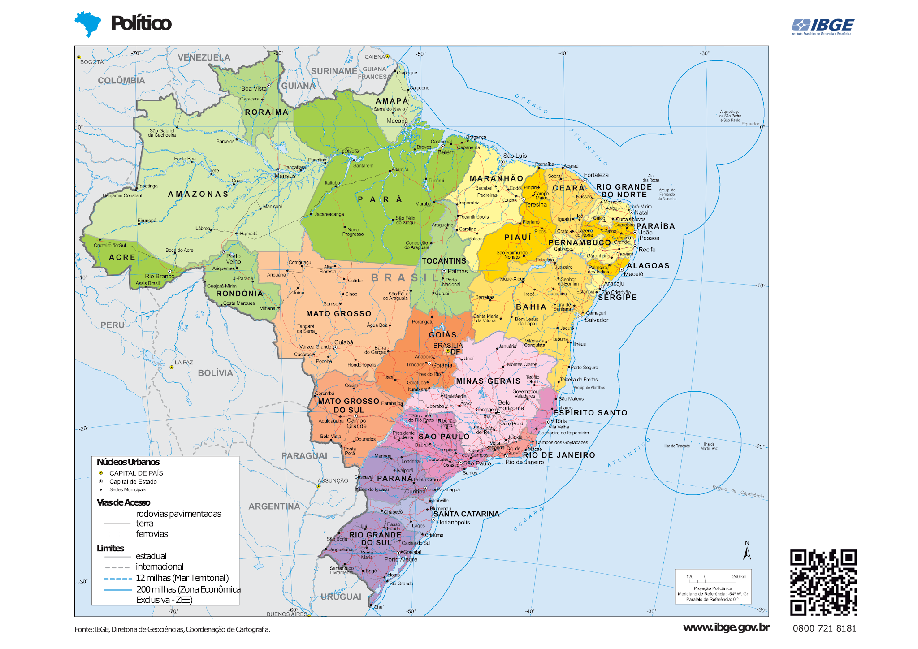

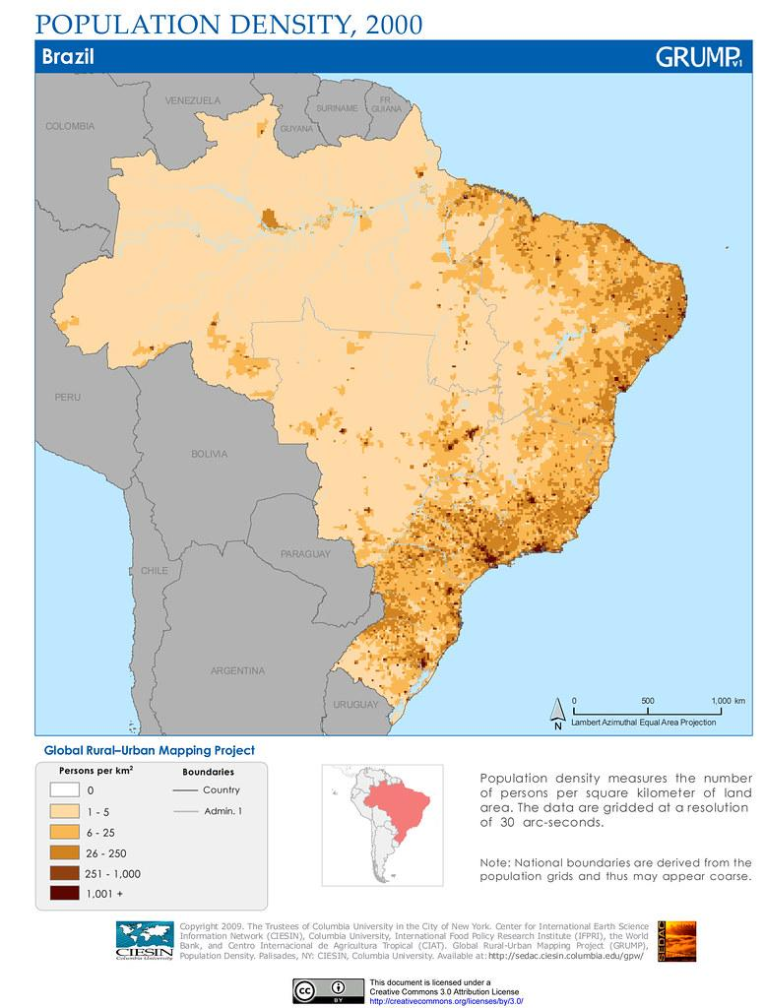

Some questions:

Find distribution of sellers and customers?

Is there a lopsided distribution of sellers and customers?

Products:
What is the general product profile?

Which is the top product sold in terms of quantity/cost?

Find this per city or region. Is there room for improvement?

Order:
Is there any pattern in orders based on region/time? or Is there seasonality/cycle in the ordering pattern?

For orders of the same items, is the experience same in all regions?

What is the customer experience in delivery? Is it good, bad, ugly

What is the average time taken to deliver products/across products?

EDA for each dataset:

https://colab.research.google.com/drive/16Irh2Jh6hWf54mke2ehHqrU7_jF4TNZ9#scrollTo=bAxrlt1Xz-Y8

Bala

Bala - additional questions
How does delivery performance change when seller and customer are in the same state versus different states?
Which customer states have high demand but weak delivery experience, making them risky growth markets?
Which product categories have high revenue but low review scores or high late-delivery rates?
Are repeat customers more tolerant of delayed deliveries than first-time customers?
Which seller cities can support regional expansion without increasing average delivery time?
Which marketing lead sources are most likely to convert into sellers with strong marketplace performance?

somsubhra
EDA_Dataviz_issues-5_6_9.ipynb

Some more questions:

Where do sellers come from, and is our funnel healthy? Do sellers recruited via different lead types/behaviour profiles end up performing differently once they're on the platform (in revenue, review scores, or cancellation rates)?

Where does the delivery timeline break down -- approval delay, carrier handoff delay, or last-mile delay and which of these stages best predicts a bad review?

Is there a geographic "logistics penalty" – do certain seller state → customer state routes systematically run late, and do those routes cluster in specific regions?

What is the true "review score attribution" -- is it driven more by delivery speed vs. estimate, or product category itself?

Do review comment title/message lengths or presence correlate with score?

Which sellers over-promised at signup vs. who under-promised and over-delivered?

If we had to design an early-warning score for "a particular seller to likely churn or get bad reviews" what combination of onboarding attributes and early order behavior would we flag?

Jeleshiya
EDA:
DVD_EDA

Few Questions :

Customer satisfaction and Reviews
What percentage of orders receive low ratings (1–2 stars) versus high ratings (4–5 stars)?

Does late delivery increase the chance of receiving a one-star review?

How does delivery time affect average review score?

Are orders delivered earlier than promised associated with higher ratings?

Which order statuses have the lowest review scores?

Which product categories receive the most one-star reviews?

Do high freight charges relative to product price lead to lower ratings?

Does seller response time to reviews relate to customer ratings?

Delivery and logistics
Which states/cities have the longest average delivery time?

Which customer regions experience the highest late-delivery rate?

Which seller states/cities have the highest late-delivery rate?

Which product categories are most likely to be delivered late?

Which sellers contribute the most late orders, after considering their order volume?

How many days late are delayed orders on average?

Does distance between seller and customer region affect freight cost and delivery time?

Seller performance
Which sellers generate the highest order volume and sales value?

Which high-volume sellers also have poor review scores or high late-delivery rates?

Which sellers should be prioritised for intervention: high sales but poor customer experience?

Are some sellers consistently delivering late across multiple product categories?

Which product categories drive the highest revenue but also carry the greatest satisfaction risk?

Is a larger product catalogue linked to better or worse customer experience?

Products, pricing, and payments
Which product categories generate the most sales revenue?

Which categories have the highest freight cost as a percentage of item price?

Do heavier or larger products have longer delivery times and lower ratings?

Do products with more photos or longer descriptions receive higher ratings?

Are expensive products rated differently from low-priced products?

sourish
EDA for order dataset:-
https://colab.research.google.com/drive/1tdl5pKbQ1OHU_MeREkPW8RBt97SGftAr?usp=sharing

https://colab.research.google.com/drive/1aUNKlYBiblYKXqbmNDi30SFV3GJFLnq4?usp=sharing

Which seller have high business contribution but poor customer experience?

Which products and sellers make marketplace growth?

18/08/26
Where are sellers concentrated and which sellers contribute most ?
Where are customers/sellers concentrated and where are delivery risks?
What proportion of orders are delivered early/on time versus late?
How severe are the delivery delays?
How long does the company take to process and deliver an order?
Delivery delay relates to customer review scores /dissatisfaction ?
How is marketplace order activity changing over time?
Does delivery delay affect customer satisfaction?

